Unit-2 Program/Software Development
Er. Bhisma Raj Joshi
Department of Computer Engineering
( NAST )

Objectives
- Introduction to program/software development - Program Development Life Cycle.
Problem Identification, Problem Analysis/Requirement Analysis Problem Design Phase, Program Coding or system development Program Testing, Debugging and Validation, Program Delivery/Implementation Program Maintenance, Documentation
- Basic Programming Tools
Example 1. Algorithm
2. Flowchart
3. Decision Table and Decision Tree
4. Pseudocode
- Comparison of Programming Tools adv & dis-adv
Exam Point of View
2 LQ – 7 and 8 marks = 15
1 Short Notes = 5

# Program and Program Development
- A program is a set of instructions written in a programming language that a computer can execute to perform a specific task or solve a problem. It translates human intentions into machine-readable code.
- Program development involves a systematic sequence of steps, including problem analysis, design, coding, testing, and maintenance for creating functional software.
- It includes iterative cycles of developing, testing, and refining the software to ensure it meets user requirements
and is free of errors.

Program Development Life Cycle
- It is also known as Software Development Life Cycle(SDLC). - It is the process used by software company or industry to design, develop and test the high-quality software product.
- It is a framework that define different tasks which are performed during software development process. - It consists of several steps which are shown in fig below.

Problem
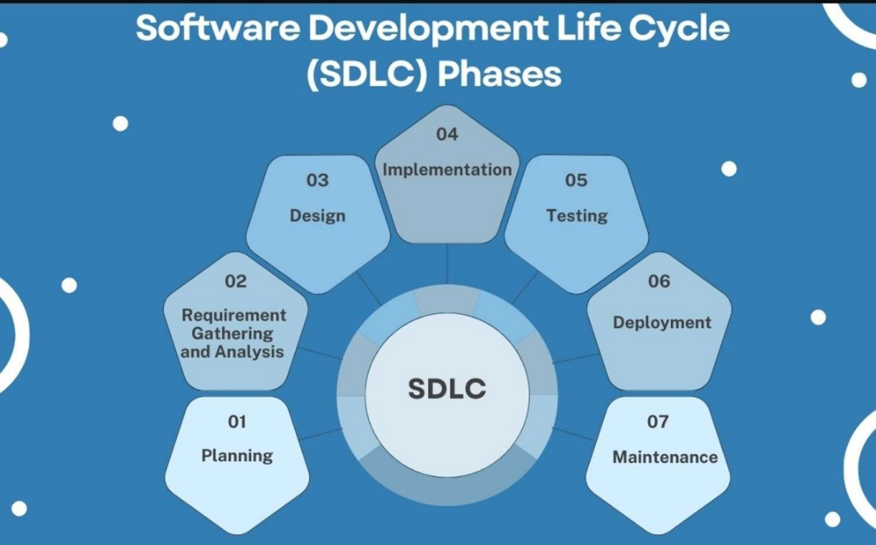
OR
Coding
and data
validation
And
Identification
Documentation
Fig:- Software Development Life Cycle 
1. Problem Identification
- The problem identification phase is a critical initial step in the Software Development Life Cycle (SDLC). It involves understanding the problem or opportunity that the software solution is expected to address. - The key points of problem identification phase are..
i) Understanding the Problem: Gather detailed requirements and insights from stakeholders to clearly understand the problem that needs to be solved.
ii) Analyzing the Problem: It involves identifying the main issue, determining what factors contribute to it, and figuring out the requirements for solving it. Essentially, it's about gaining a clear and complete understanding of the problem before deciding on a solution.

2. Requirement Gathering and Analysis
- The requirement gathering phase is all about collecting information from various sources to understand what the stakeholders need from the system. - The various techniques for gathering requirements are
Interviews: Conduct one-on-one/group interviews with stakeholders to gather in-depth insights.
Surveys: Use structured surveys to collect information from a larger audience.
Workshops: Organize collaborative workshops to discuss requirements and brainstorm solutions.
Observation: Observe users in their natural environment to understand how they interact with current systems.
Document Analysis: Review existing documentation, such as business plans and user manuals, to extract relevant information.
- Once the requirements are gathered, the next step is to analyze them to ensure they are clear, complete, and feasible.
- The feasibility study analyzed the proposed system from different aspects so that the development team or company can conclude how practical or beneficial the system will be to the organization.
- The different levels of feasibility study includes
⮚ Economic feasibility
⮚ Technical feasibility
⮚ Operational feasibility
⮚ Schedule feasibility
⮚ Legal feasibility

assignment 1
Define feasibility study, what is its importance in SDLC. Explain its various types in details.

3) Design
- It is concerned with the design of the wireframes to illustrate how the software will look and function. It involves designing of various things such as input design, processing and output design etc.
- While designing a system the different system design tools are used. some examples includes.
a)Algorithm:- It is a finite sequence of instruction for solving a problem. b)Flowchart:- It is the pictorial representation of an algorithm. c)ER diagram:- The entity-relationship diagram is an overall logical structure of a database that can be expressed graphically.
d) Decision Table:- A decision table is a structured way to represent conditions and corresponding actions in a tabular format.

4. Implementation or Coding
- The system design needs to be implemented to make it a workable system so after the system design the programmers begin to develop the program by using a suitable high level programming language based on the design specifications created in the previous stage.
- In system development the following process are done. - Convert the logical structure into program
- Database is created
- Version control and integration
- The coding phase is crucial because it directly converts plans into a functional product.
5. Testing and Data Validation
- It is an investigation conducted to provide stakeholders with information about the quality of the product or service under test.
- In this phase the testing and debugging task are performed. If any inconsistencies errors or problems are found then they are corrected by improving the individual units.
- There are 2 types of testing
a) Black Box testing:- Process of testing the whole project and test whether a whole system is functioning or not.
b) White Box Testing:- In white box testing the particular model or unit is tested which helps to test the software internal logic.
Testing is also divided into two types as:-
a) Alpha Testing
- It is the final level of QA team’s testing to ensure that your program is ready for release outside of your organization. Its main goal is to ensure that the software is bug-free.
b) Beta Testing
- In beta testing the final product or software is distributed to a small group of genuine users and users are invited to provide comments and review on the software’s performance.

- Data Validation is the process of ensuring that data entered into a system is accurate, complete, and meets predefined criteria.
Types of Data Validation:
1.Format Validation: Ensures data follows a specific format (e.g., email, phone number).
2. Range Validation: Checks if data falls within a specified range (e.g., age between 1 and 100).
3. Consistency Validation: Verifies data across related fields (e.g., matching password and confirm password).
4. Presence Validation: Ensures mandatory fields are not left blank. 5. Uniqueness Validation: Confirms that data entries are unique (e.g., unique usernames).
6. Deployment
- Once the coding and testing of the software has been completed, the next phase starts to create a complete package which is called setup file to deliver or deploy the system for the client or end users.
- The software is installed in the client’s computer for the final implementation and evaluation of the system.
- The major steps involve in this phase are:
▪ Installation of hardware and software
▪ User training
▪ Providing instruction manuals
▪ Review and Feedback
7. Maintenance and Documentation
- It begins after system deployment . This is the phase that conduct the periodic maintenance of hardware and software to ensure it continue to function as it was design.
- It involves fixing bugs, updating features, and optimizing performance based on user feedback or evolving requirements.
- This phase ensures the software remains reliable, secure, and aligned with business needs over time.
- The final and the last phase of the program development life cycle is the documentation phase.
- In this phase a technical writer prepares a reports, project documents, contracts and agreements related with project.
- It includes the overall description of the system including the reports as well as instruction manuals that ensure smooth knowledge transfer, simplifies troubleshooting and supports future enhancement.
- This phase happens throughout the entire SDLC to keep all documents updated with any changes.
Assignment 2
why testing phase is necessary in SDLC? Write down the major differences between Testing and Debugging.
Assignment:3
Which phase of SDLC is more important in what context of good program design and development? Discuss with logic.
# Program / Software Design Tools
- Software Design Tools (SDT) refer to the various tools and applications used by developers and designers to plan, create, visualize, and document software systems.
- These tools help in translating concepts and requirements into concrete designs and models that guide the actual development process. - Below are the major program design tools:
1. Algorithm
2. Flowchart
3. Decision Table and Decision Tree
4. Pseudocode
1. Algorithm
- The program design tools that contain step by step procedure or sequential steps which are written by using English language for solving specific problem.
- Algorithms are written to show how a program or a function perform its calculation and data processing.
Characteristics / Features of an Algorithm
- An algorithm uses finite number of logical steps.
- Each step must be defined precisely and unambiguously. - Every steps should be executed exactly in finite time.
- It should be independent of programming language.
1. Write an algorithm to add two numbers entered by users.
Step1 start
Step2 create variable num1,num2 and result Step3 take input value from user
Step4 result=num1+num2
Step5 display the result
Step6 stop
2. Write an algorithm to calculate the simple interest.
Step1: START
Step2: create variable P,T,R and S.I
Step3: take value of P,T,R from user
Step4: S.I = PTR /100
Step5: display the S.I
Step6: STOP
3. Write an algorithm to find the area of circle.
Step1: START
Step2: Create variable r for radius
Step3: Take input value of radius (r)
Step4: Set π = 3.14
Step5: Compute Area = π × r × r
Step6: Display Area
Step7: END
4. Write an algorithm to find the greatest among two number.
Step1: START
Step2: Create variable a and b
Step3: Read two numbers (a, b)
Step4: IF a > b THEN
display a is greatest
ELSE
b is greatest
Step5: END
5. Write an algorithm to check the entered number is even or odd.
Step1: START
Step2: Create variable n
Step3: Read number (n) from user
Step4: IF n % 2 == 0 THEN
Display "Even"
ELSE
Display "Odd"
Step5: END
6. Write an algorithm to convert Celsius to Fahrenheit.
Step1: START
Step2: Create variable (C) to store Celsius
Step3: Read temperature in Celsius (C)
Step4: F = (C × 9/5) + 32
Step5: Display F
Step6: END
Advantages of Algorithm
- Algorithms provide a step-by-step approach to solving a problem, making the solution clear, logical, and easy to follow.
- Algorithms are designed to optimize the use of resources such as time and memory.
- Once an algorithm is developed, it can be reused for similar problems, saving time and effort.
- Algorithms provide a clear framework for testing and debugging.
Dis-advantages of Algorithm
- Designing a detailed and efficient algorithm for complex project will be time consuming.
- Algorithms are designed to address specific problems with predefined
inputs and conditions so limited flexibility.
2. Flowchart
- The diagrammatic or pictorial representation of different steps involved in algorithm to solve specific problem is called Flow Chart.
- It is the best method of designing the solution about program and provide excellent guide of writing the code of the problems.
- It uses different geometrical shapes, symbols to represent different action involves in problem solving.
The different symbols used in Flowchart are:-
Decision
making
1. Draw a flowchart to find sum of two numbers
2. Draw a flow chart to find greatest among two.
3. Draw a flowchart to find simple interest.
4. Draw a flow chart to find the
entered number is even or odd.
5. Draw a flowchart to find area of circle.
Advantages of flowchart
- Improved Understanding:- Flowcharts visually represent processes, making complex workflows easy to understand for both technical and non technical audiences.
- Efficient Problem-Solving:- By breaking down a process into individual steps, flowcharts help identify errors and solve problem.
- Easy Modification and Maintenance:- Flowcharts allow for easy updates and modifications when processes or requirements change. Disadvantages
- Time-Consuming:- Designing detailed and accurate flowcharts, especially for complex systems or processes.
- Difficulty in Managing Complex Processes:
3. Decision Table
- A decision table is a tabular method used to represent and analyze complex decision-making processes, particularly used in systems design.
- It provides a structured framework to list all possible conditions and corresponding actions to ensure complete coverage of all scenarios.
QN-1 Create a decision table to determine the eligibility of students for a scholarship based on their academic performance and financial need. Consider the following conditions:
1) GPA>=3.70 and annual family income is low(<$30,000) provides 100% scholarship.
2) GPA>=3.70 and annual family income is Moderate($30,00- $60,000) provides 75% scholarship.
3) GPA>=3.70 and annual family income is high (>$60,000) provides 50% scholarship.
4) GPA>=3.50 and annual family income is low (<$30,000) provides 75% scholarship.
5) GPA>=3.50 and annual family income is moderate ($30,00- $60,000) provides 50% scholarship.
6) For other cases there is no scholarship.

